CS0016 INTRO TO COMP PROG APPS
Assignment 4 – Allowance
Before you start….
Create a folder called Lab4 inside your CS0016Python folder.
When writing your programs make sure you include the 4 comments at the top
Programs
1. Start up IDLE3.8 and open a scripting window
2. Write a program, allowance, to calculate allowance for business trips. The program calculates the total allowance owed an employee using the following rules:
- The employee is paid 55 cents for each mile traveled if the distance is below 150, 52 cents per mile if the distance was 150 or more but less than 300 and 47 cents per mile if the distance was 300 or more miles.
- The employee receives 28% of the amount of meal expenses if the amount is less than $150 otherwise the employee receives 35% of the amount
- For lodging, the whole amount is paid if lodging cost was more than 200. If the cost was between 100 and 200 inclusive then the allowance is 50% otherwise there is no allowance.

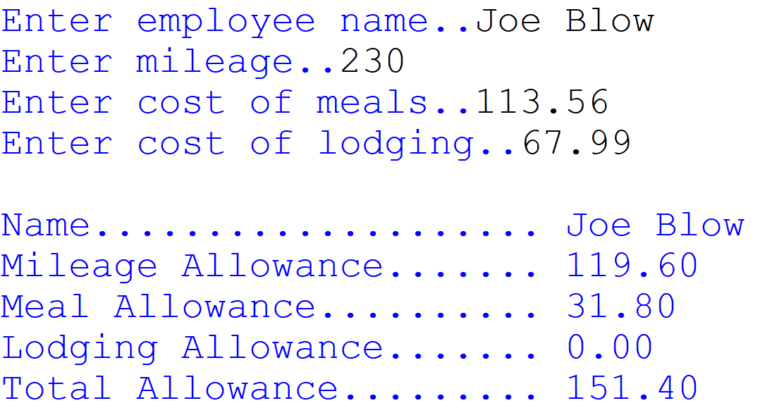
3. Your program does not need to check for input error.
4 Upload your completed program to Canvas by the start of the next class.

